|  |
| --- |
| ***Date: / / 18***  **[cloud computing]** |
|  |

Practical:11

**AIM: Openstack Cloud Configuration**

Submitted By: Samip Shah

Enrollment No: 15012011045



**GANPAT UNIVERSITY**

**U. V. Patel College of Engineering**

**Computer Engineering Department**

**What is OpenStack?**

OpenStack is a collection of open source software modules that provides a framework to create and manage both public cloud and private cloud infrastructure.

**Introduction to OpenStack**

OpenStack lets users deploy virtual machines and other instances that handle different tasks for managing a cloud environment on the fly. It makes horizontal scaling easy, which means that tasks that benefit from running concurrently can easily serve more or fewer users on the fly by just spinning up more instances. For example, a mobile application that needs to communicate with a remote server might be able to divide the work of communicating with each user across many different instances, all communicating with one another but scaling quickly and easily as the application gains more users.

And most importantly, OpenStack is open source software, which means that anyone who chooses to can access the source code, make any changes or modifications they need, and freely share these changes back out to the community at large. It also means that OpenStack has the benefit of thousands of developers all over the world working in tandem to develop the strongest, most robust, and most secure product that they can.

**OpenStack Configuration**

**Step by step**

**Step 1:**

Login to your Linux operating system and open terminal

**Step 2:**

Go to root directory by firing following command

1. *sudo –i*

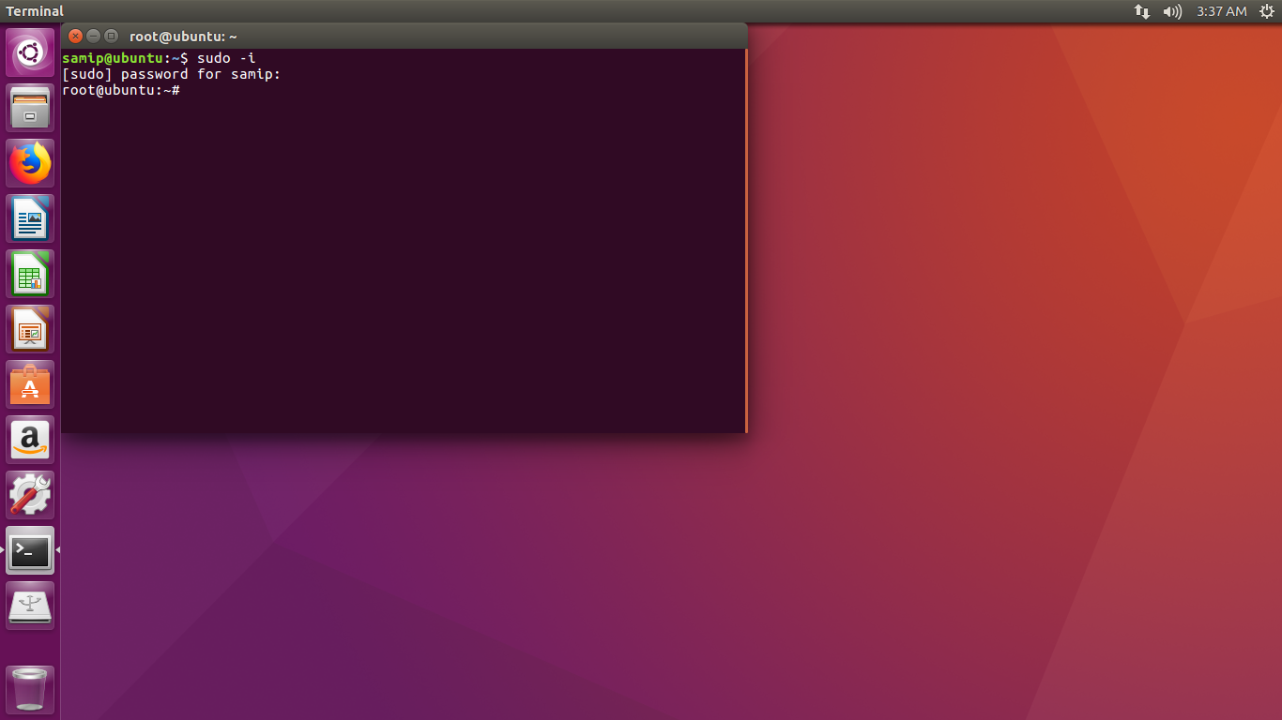

**Step 3**

Open the sudo file by firing following command

1. *visudo*

Now modify sudo file as

%sudo ALL=(ALL:ALL) ALL

*stack ALL=(ALL) ALL* 🡨------add this line

(It will allow all members of this group to execute all commands)

Press “ctrl+x” to save and exit editor.

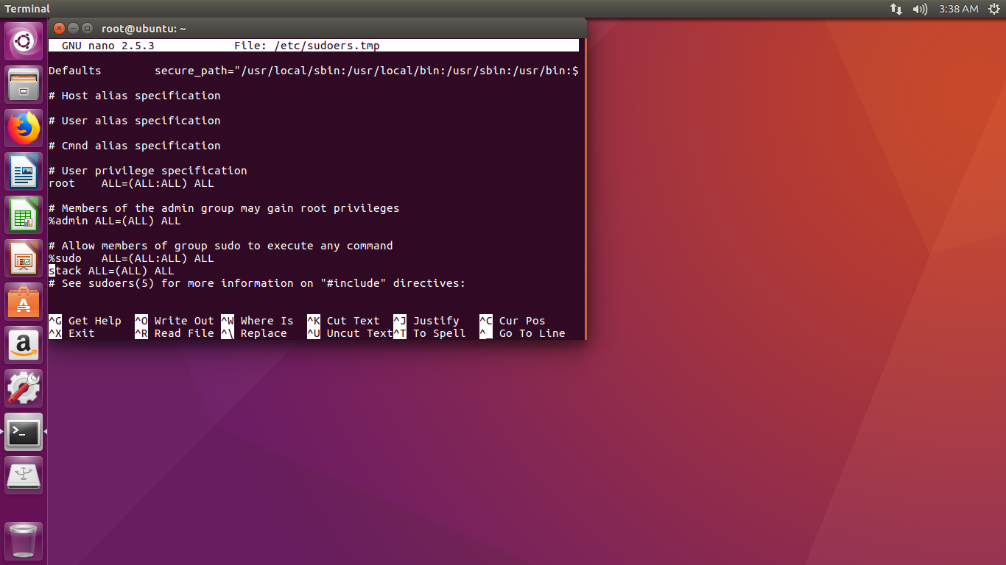

**Step 4:**

Now create a new user by firing following command

1. *adduser stack*

It will ask for password. Provide appropriate password and give enter to set some default values.

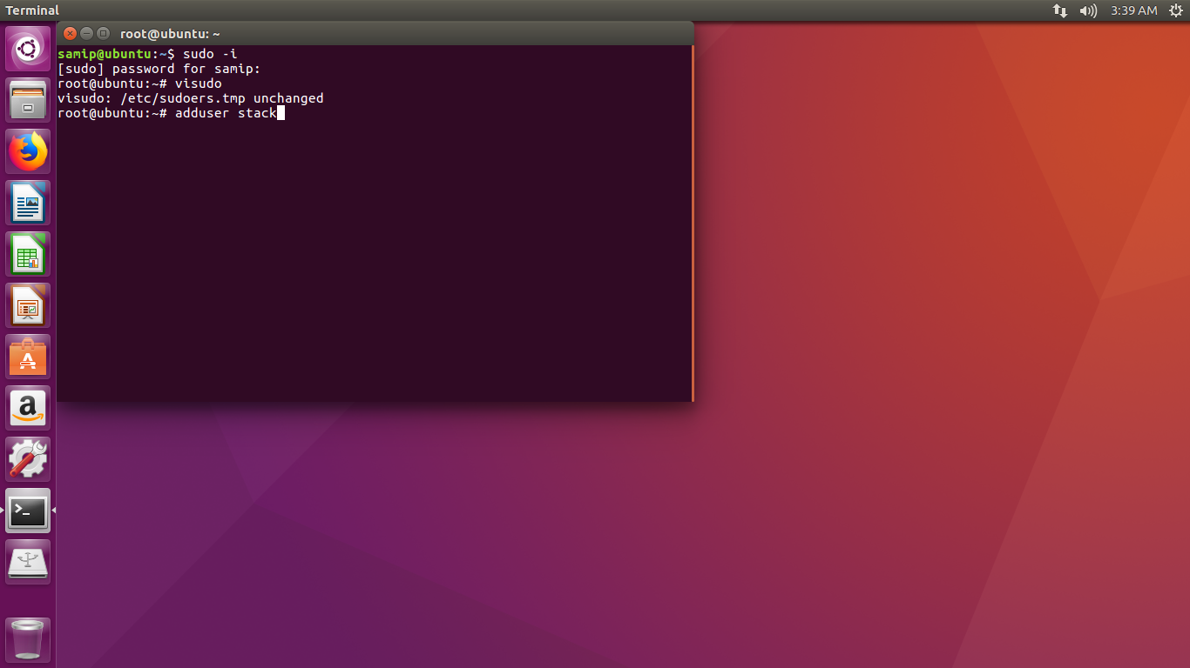

**Step 5:**

Login to Stack user and open terminal

**Step 6:**

Now install git. To install git fire following command

1. *sudo apt-get install git*

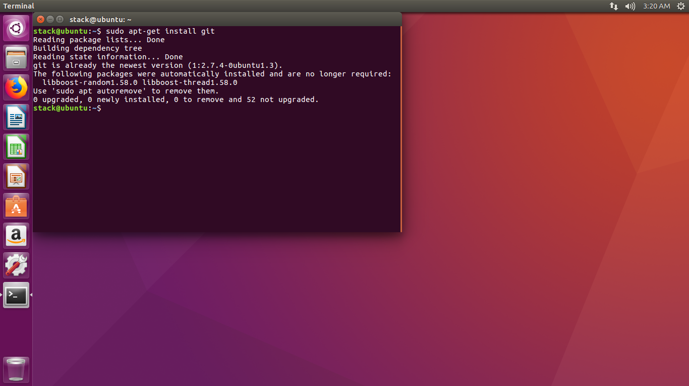

**Step 7:**

Now download devstack. To download it, fire following command

1. *git clone https://git.openstack.org/openstack-dev/devstack*

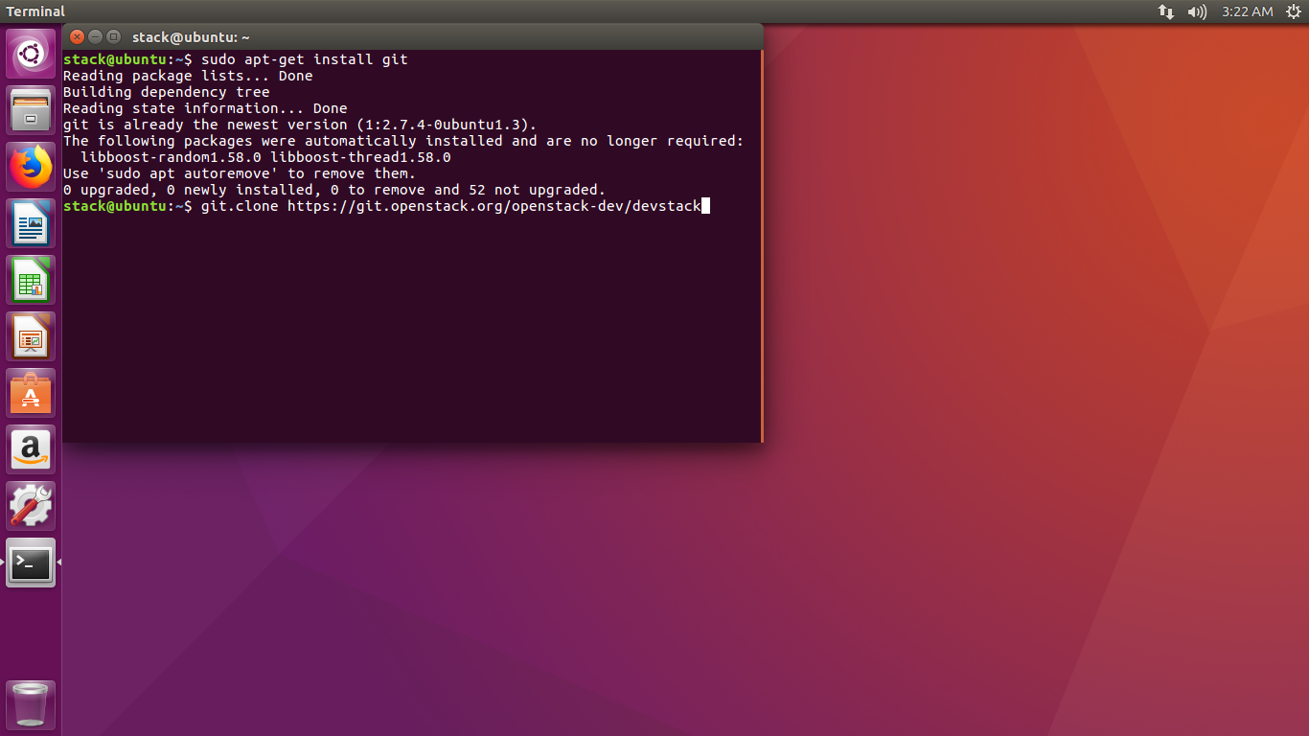

**Step 8:**

After downloading devstack fire following commands.

1. *cd devstack*
2. *cd samples*
3. *cp local.conf ../*
4. *nano local.conf*

Enter your local IP address in local.conf below SERVICE_PASSWORD.

(Your local IP address will be in connection information)

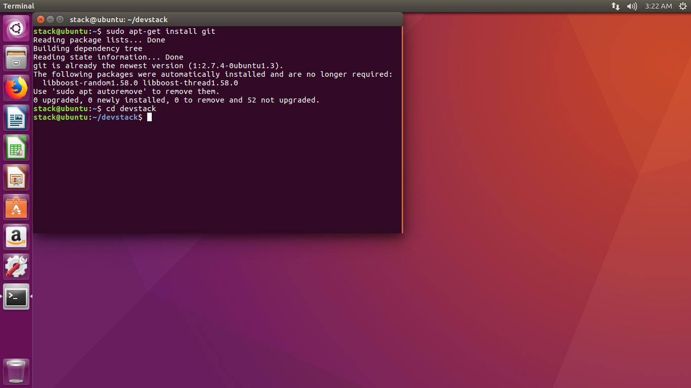

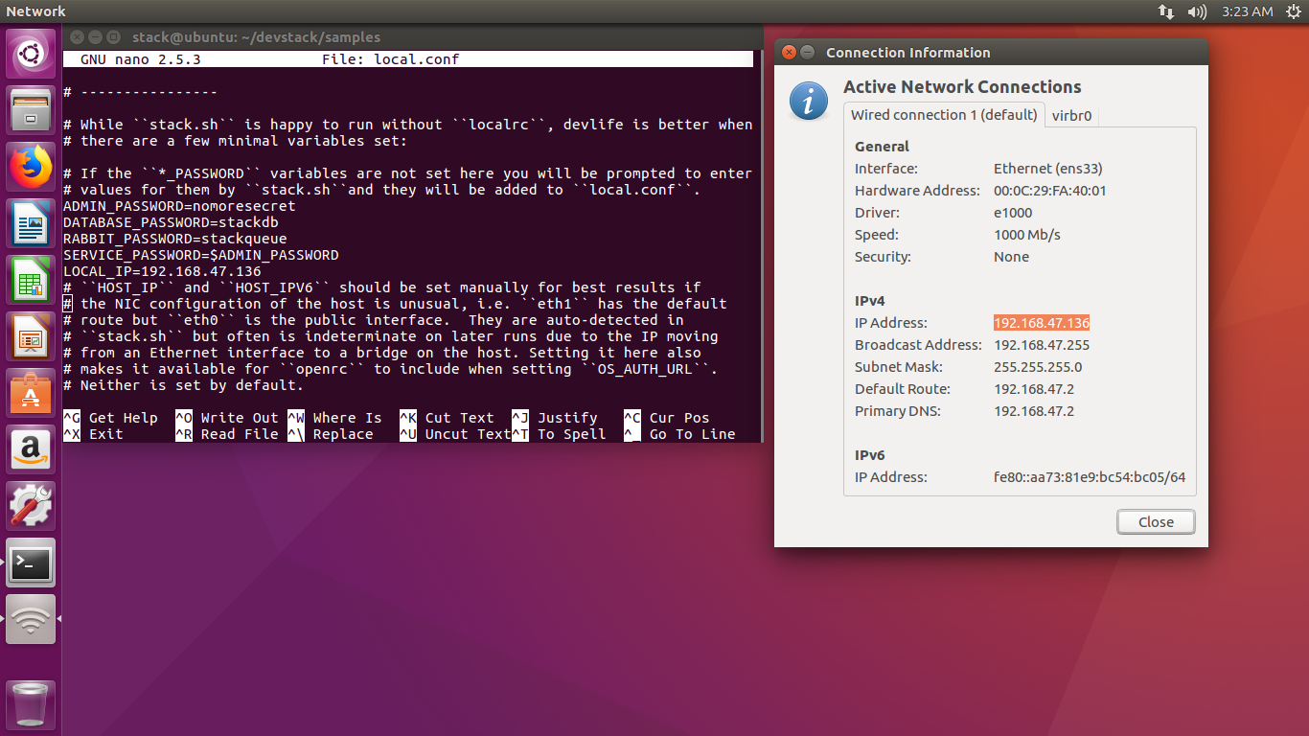

**Step 9:**

Fire following commands

1. *cd ..*
2. *./stack.sh* 🡨 this command will take a moment to download

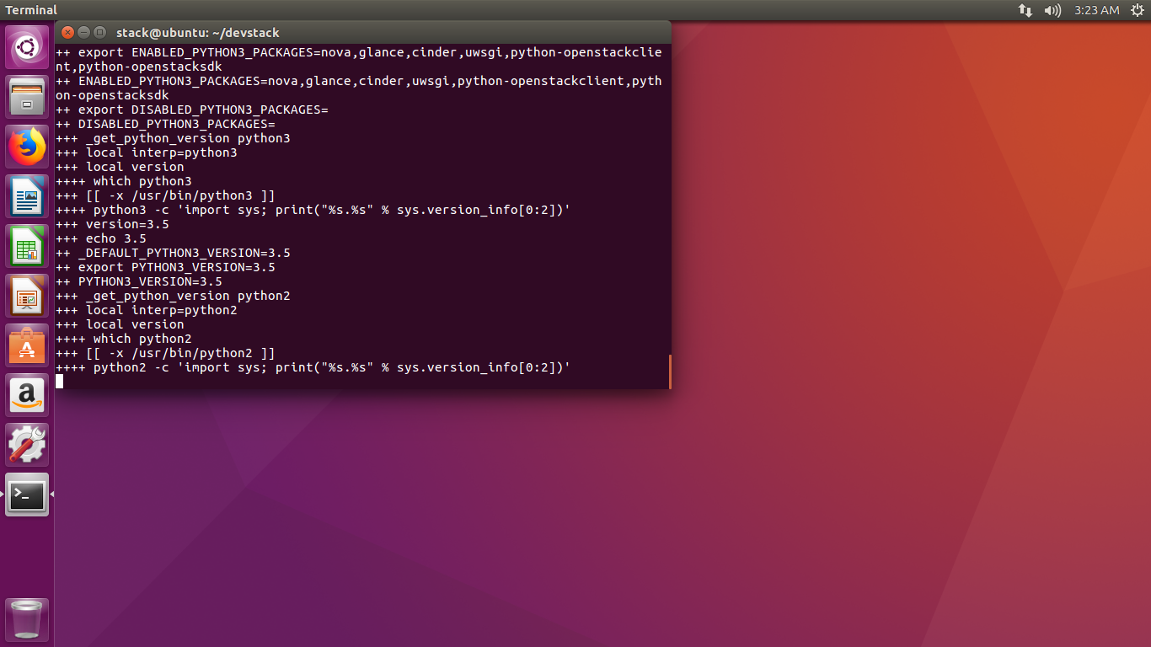

**Step 10:**

Your host IP will be generated and default login id will be

“admin” and “demo”. You can use either of two. And password is

“nomoresecret”.

**Step 11:**

Enter your host IP as url in the browser and you will be directed towards the OpenStack Dashboard.

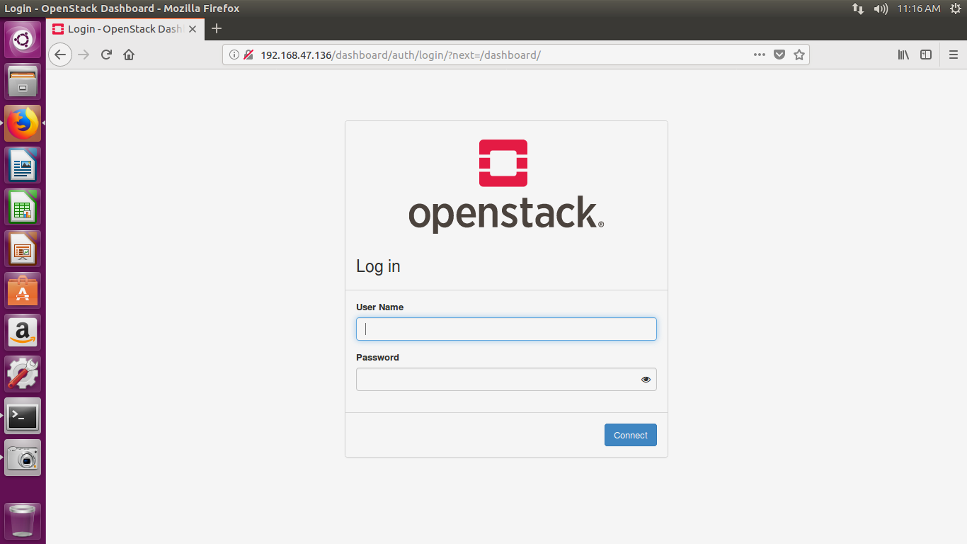

**Step 12:**

Enter login details

**Step 13:**

Go to Project -> Compute -> Instances. Click on launch instances

**Step 14:**

Select image file and click upload

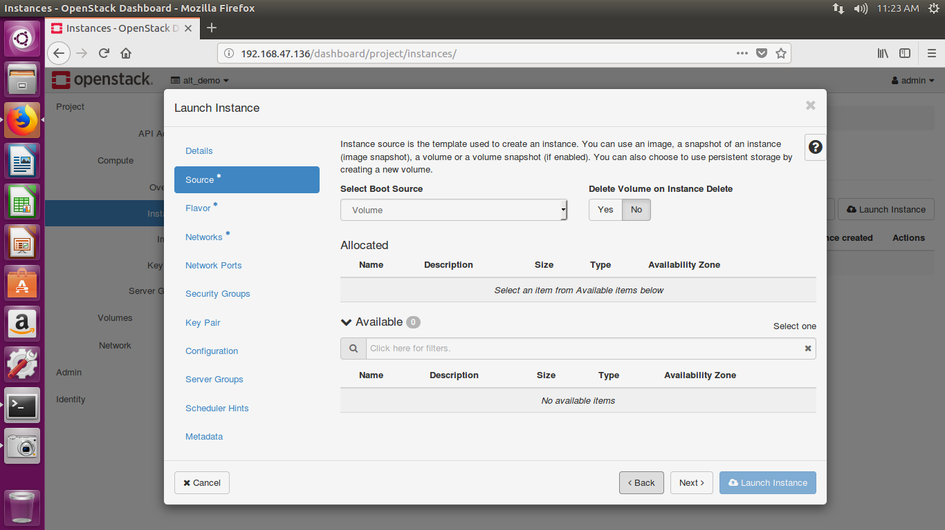

**Step 15:**

Select flavour of your instance

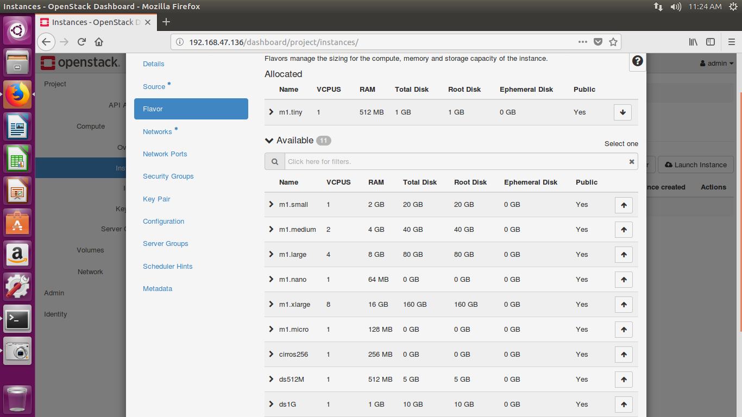

**Step 16:**

Create your key pair and click on next.

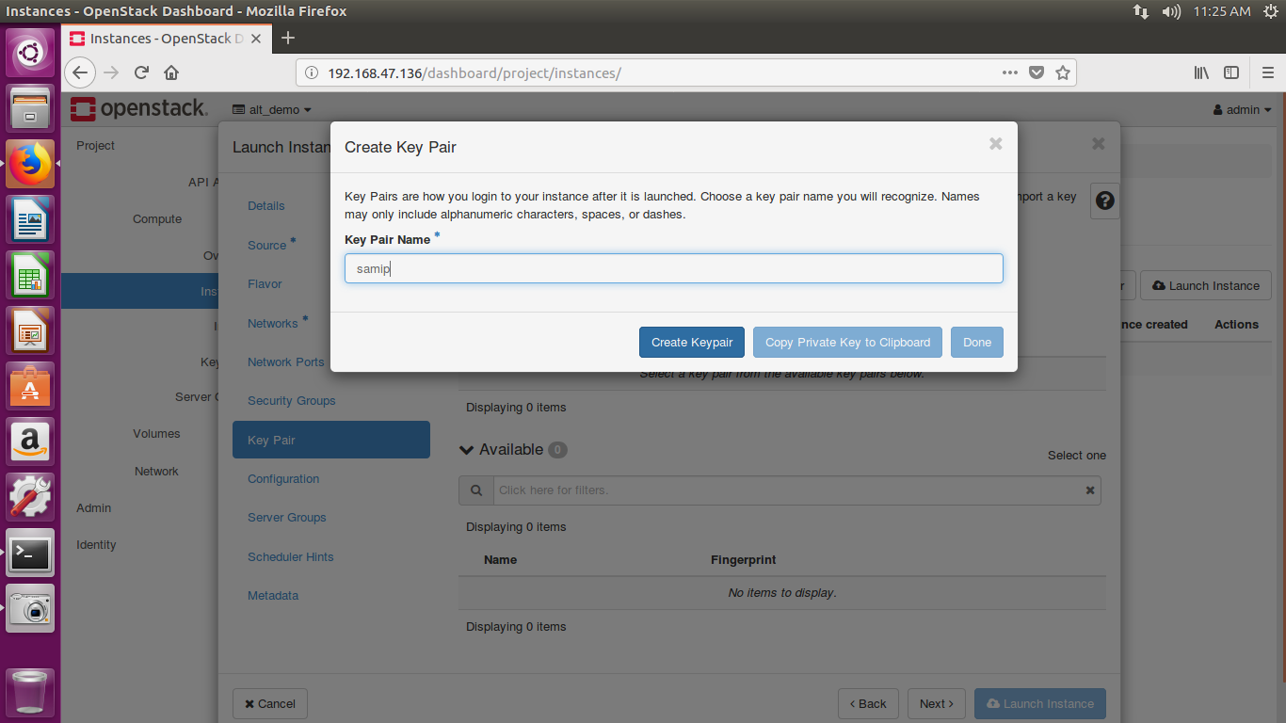

**Step 17:**

Set the metadata according to your requirements.

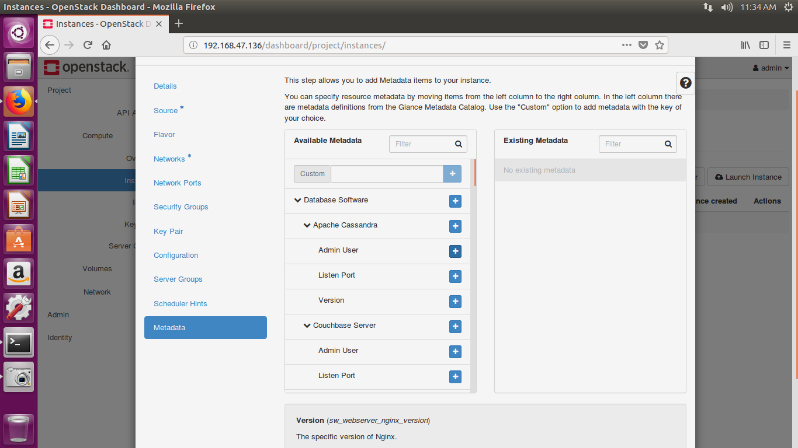

**Step 18:**

Click on launch instance. And your instance will launched in few seconds.

